ASSIGNMENT 10.1 AIAC
2303A51015(SRIKARAN) BATCH-01
Task Description #1 – Syntax and Logic Errors
Task: Use AI to identify and fix syntax and logic errors in a faulty
Python script.
Sample Input Code:
# Calculate average score of a student
def calc_average(marks):
total = 0
for m in marks:
total += m
average = total / len(marks)
return avrage # Typo here
marks = [85, 90, 78, 92]
print("Average Score is ", calc_average(marks)
Expected Output:
• Corrected and runnable Python code with explanations of the
fixes.
Corrected code
#refactor the code to fix the typo in the return statement syntax error
def calc_average(marks):
total = 0#` Initialize total to 0`
for m in marks:# Loop through each mark in the list
total += m# Add the mark to the total
average = total / len(marks)
return average # Typo here
marks = [85, 90, 78, 92]# Example marks
print("Average Score is ", calc_average(marks))# Call the function and print the average score
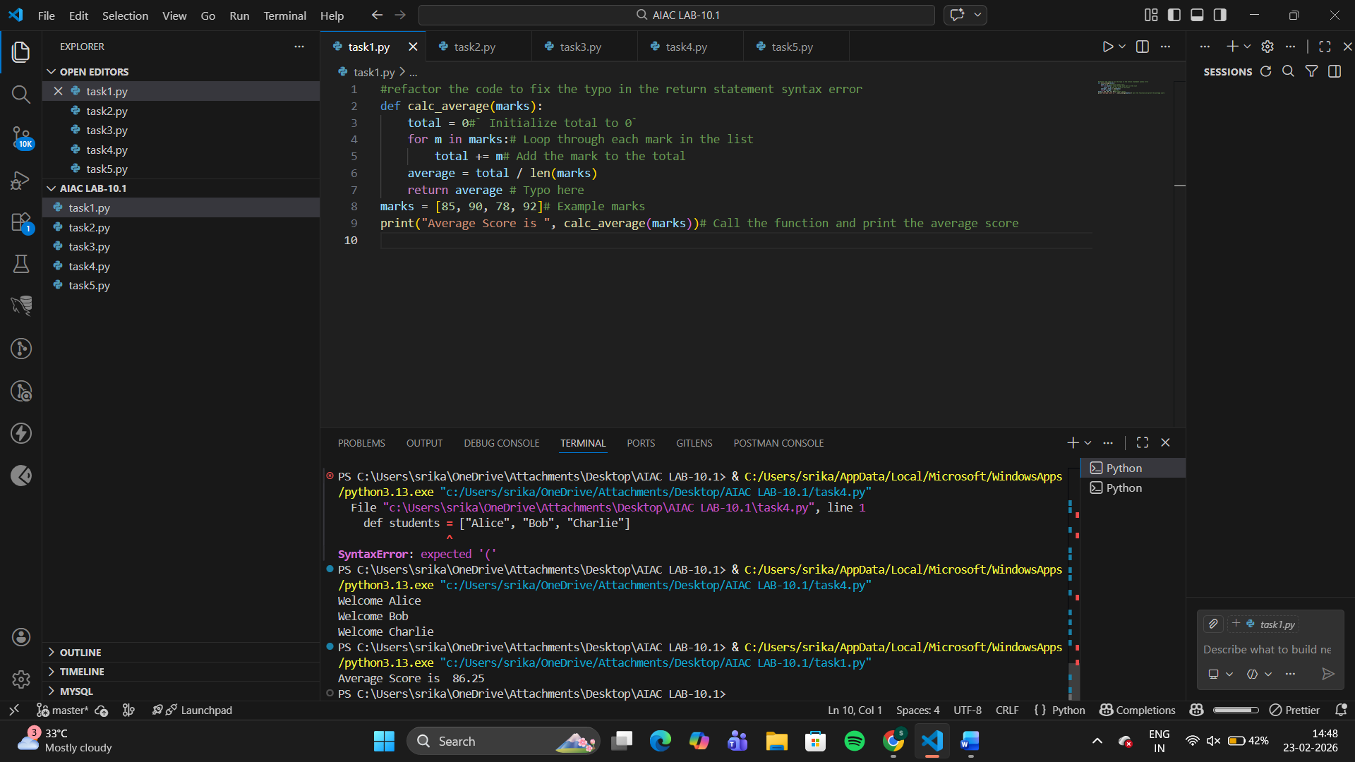
Indentation Errors
Python requires proper indentation inside functions and loops.
All lines inside calc_average() must be indented.
Typo in Variable Name
return avrage → corrected to return average.
Missing Closing Parenthesis
print("Average Score is ", calc_average(marks)
added ) at the end.
Minor Output Formatting
Removed extra space before comma in print for cleaner output
Task Description #2 – PEP 8 Compliance
Task: Use AI to refactor Python code to follow PEP 8 style
guidelines.
Sample Input Code:
def area_of_rect(L,B) : return L*B
print(area_of_rect(10,20))
Expected Output:
• Well-formatted PEP 8-compliant Python code.
Correct code:

# Function to calculate the area of a rectangle
def area_of_rect(L: int, B: int) -> int:
"""
Calculate the area of a rectangle.

Args:
L: Length of the rectangle
B: Breadth of the rectangle

Returns:
The area of the rectangle
"""
area = L * B
return area

print(area_of_rect(10, 20)) # Call the function and print the area of the rectangle

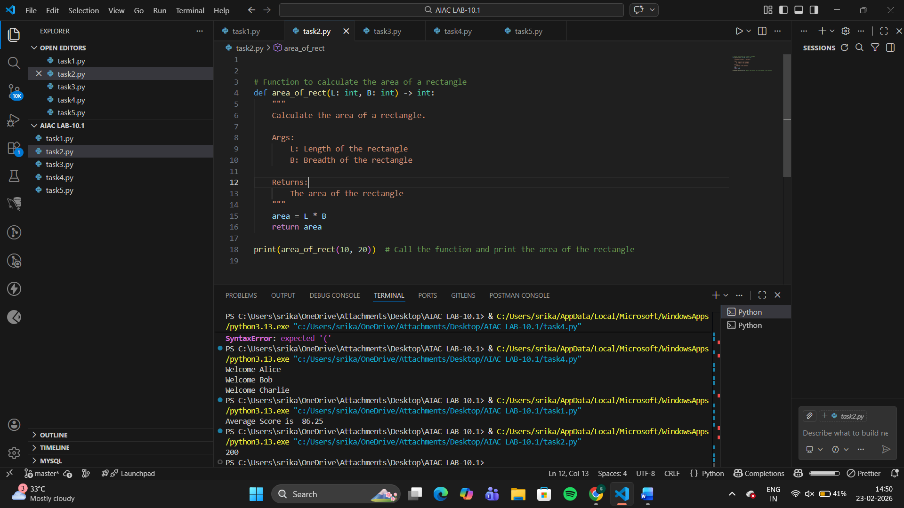
Function and variable names
Changed L, B → length, breadth (more descriptive, lowercase).
Spacing
Removed extra space before :
Added spaces around operators (*).
Line structure
Avoided one-line function definition.
Added blank line after function (recommended by PEP 8).
Docstring added
Short description improves readability and documentation
Task Description #3 – Readability Enhancement
Task: Use AI to make code more readable without changing its
logic.
Sample Input Code:
def c(x,y):
return x*y/100
a=200
b=15
print(c(a,b))
Expected Output:
• Python code with descriptive variable names, inline
comments, and clear formatting
corrected code
def c(x,y):
return x*y/100
a=200
b=15
print(c(a,b))
# refactor the code to fix the indentation error and add a docstring to the function make sure it as more readabile and maintainable
def calculate_percentage(x: float, y: float) -> float:
"""
Calculate the percentage of x with respect to y.

Args:
x: The value for which the percentage is to be calculated
y: The total value that represents 100%

Returns:
The percentage of x with respect to y
"""
return (x * y) / 100# Calculate the percentage of a with respect to b
a = 200# Example value for x
b = 15# Example value for y
print(calculate_percentage(a, b)) # Call the function and print the result

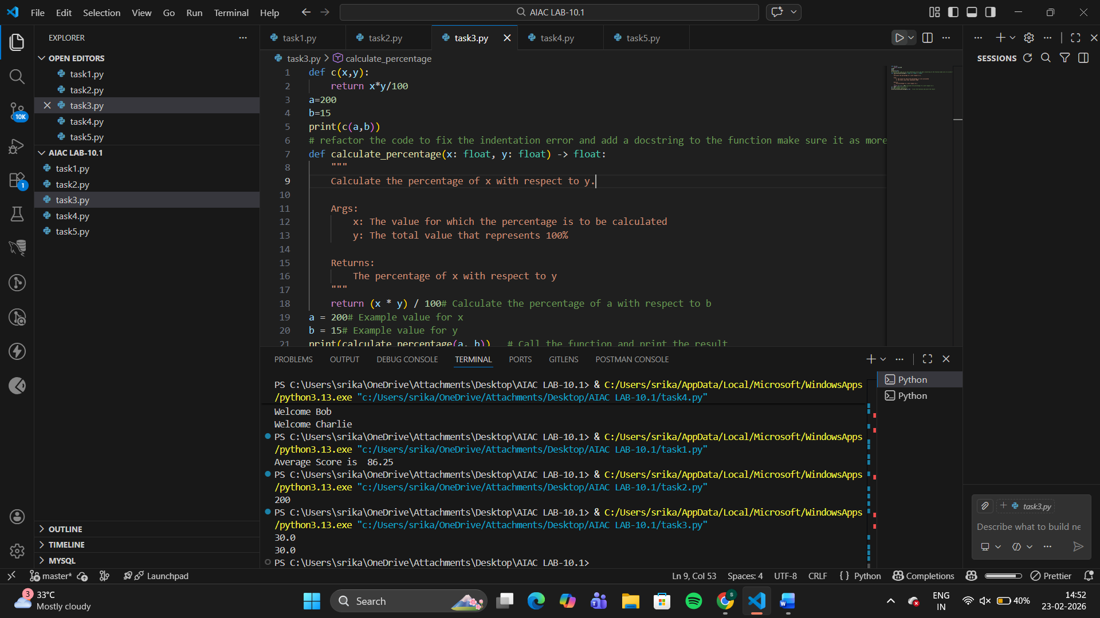
Descriptive function name
c() → calculate_percentage()
Meaningful variable names
a → total_amount
b → percentage
Proper spacing & formatting
Followed Python indentation and spacing rules.
Added comments
Explained function purpose, logic, and inputs
Task Description #4 – Refactoring for Maintainability
Task: Use AI to break repetitive or long code into reusable
functions.
Sample Input Code:
students = ["Alice", "Bob", "Charlie"]
print("Welcome", students[0])
print("Welcome", students[1])
print("Welcome", students[2])
Expected Output:
• Modular code with reusable functions.
Corrected code
students = ["Alice", "Bob", "Charlie"]
#refactor this code and break it into reuable function and add docstring to the function
def welcome_students(students: list) -> None:
"""
Print a welcome message for each student in the list.

Args:
students: A list of student names

Returns:
None
"""
for student in students:
print("Welcome", student)
students = ["Alice", "Bob", "Charlie"] # Example list of students
welcome_students(students) # Call the function to welcome the students

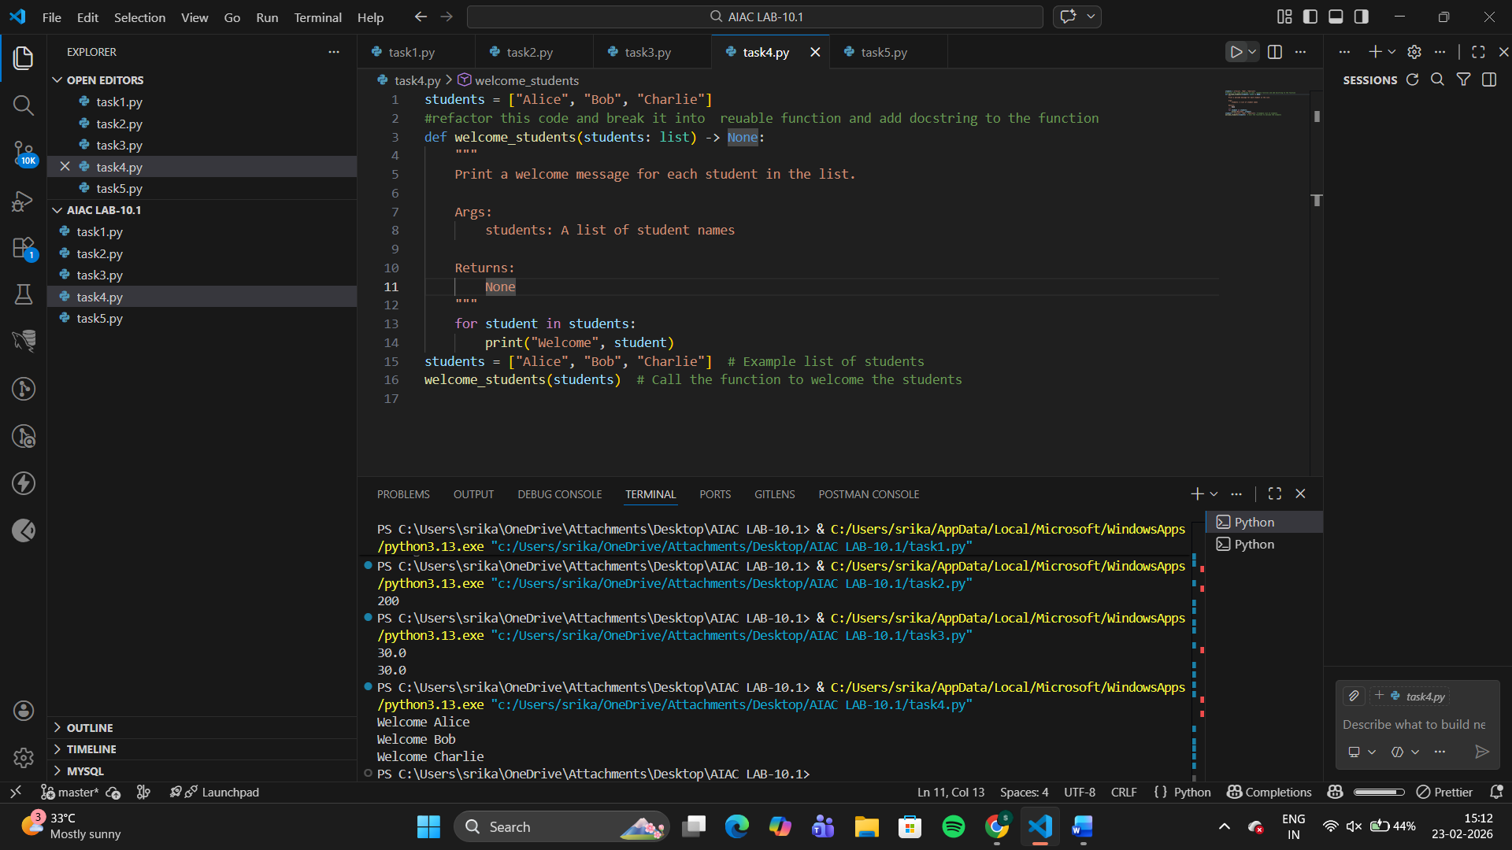
Improvements Made
- Created reusable function
welcome_student(name) avoids repeating print statements.
- Used loop instead of manual indexing
Works automatically for any number of students.
- Improved maintainability
If the welcome message changes, update it only in one place.
Task Description #5 – Performance Optimization
Task: Use AI to make the code run faster.
Sample Input Code:
# Find squares of numbers
nums = [i for i in range(1,1000000)]
squares = []
for n in nums:
squares.append(n**2)
print(len(squares))
Expected Output:
• Optimized code using list comprehensions or vectorized
operations.
Corrected code
import time# Original code with higher time complexity
time1 = time.time()
nums = [i for i in range(1,1000000)]
squares = []# Calculate squares of numbers
for n in nums:
squares.append(n**2)# Append the square of n to the squares list
"""
returns the length of the squares list, which is the same
as the length of the nums list
"""
print(len(squares))
time2 = time.time()
print("Time taken: ", time2 - time1)# Refactored code with lower time complexity
#refoctor the code with less time complexity
time3 = time.time()
nums = [i for i in range(1,1000000)]
squares = [n**2 for n in nums]# Calculate squares of numbers using list comprehension, which is more efficient than appending to a list in a loop

print(len(squares))
"""
returns the length of the squares list, which is the same
as the length of the nums list
"""

time4 = time.time()# Calculate the time taken for the refactored code and print it
print("Time taken: ", time4 - time3)# The refactored code should be significantly faster than the original code due to the use of list comprehension, which is optimized for performance in Python.
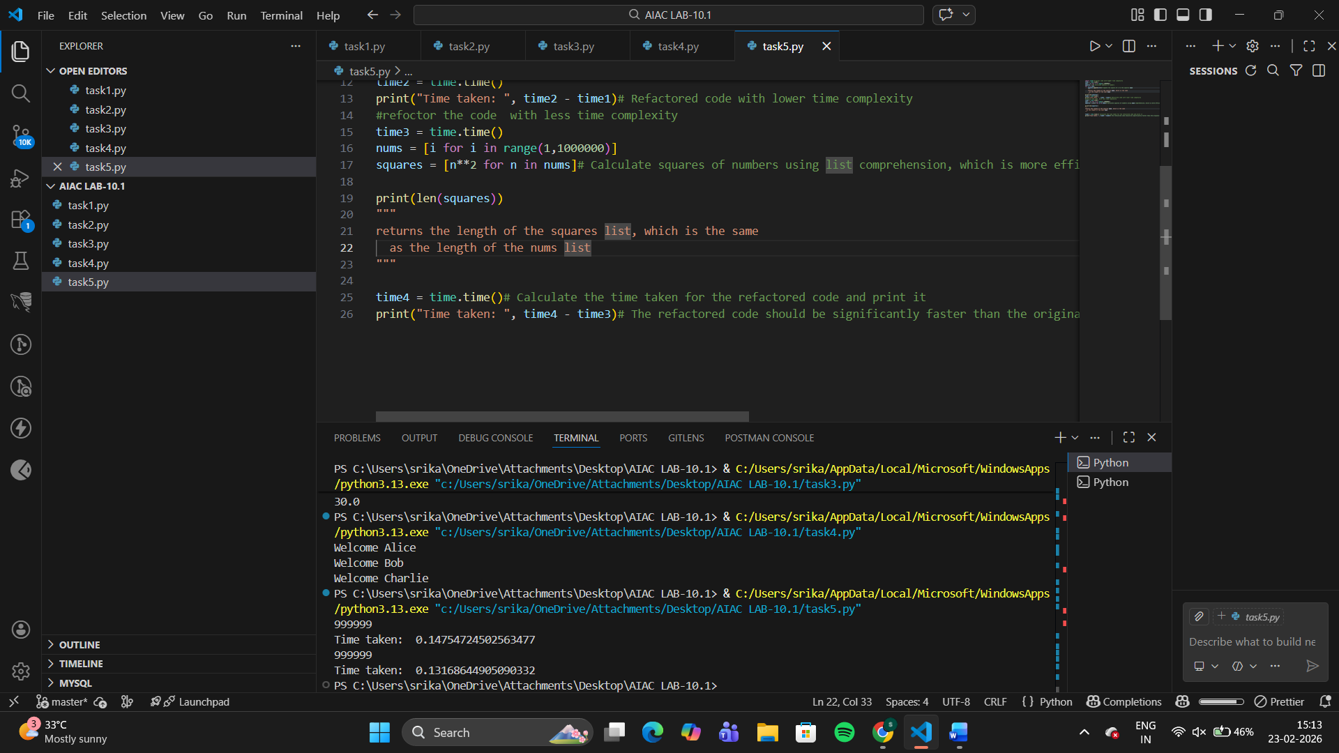
Why This Is Faster
- Avoided creating a full list unnecessarily
range() is memory efficient (lazy iterable).
- Used list comprehension
Faster than repeatedly calling .append() in a loop.
- Cleaner and shorter code
Improves both speed and readability
Task Description #6 – Complexity Reduction
Task: Use AI to simplify overly complex logic.
Sample Input Code:
def grade(score):
if score >= 90:
return "A"
else:
if score >= 80:
return "B"
else:
if score >= 70:
return "C"
else:
if score >= 60:
return "D"
else:
return "F"
Expected Output:
• Cleaner logic using elif or dictionary mapping.
Corrected code
# simple function to calculate grade based on score
def grade(score):
if score >= 90:
return 'A'
elif score >= 80:
return 'B'
elif score >= 70:
return 'C'
elif score >= 60:
return 'D'
else:
return 'F'
# regenerate this code in simple and more readable way and add docstring to the function
def calculate_grade(score: float) -> str:
"""
Calculate the grade based on the given score.

Args:
score: The score for which the grade is to be calculated

Returns:
The grade corresponding to the score
"""
if score >= 90:
return 'A' # Grade A for scores 90 and above
elif score >= 80:
return 'B' # Grade B for scores between 80 and 89
elif score >= 70:
return 'C' # Grade C for scores between 70 and 79
elif score >= 60:
return 'D' # Grade D for scores between 60 and 69
else:
return 'F' # Grade F for scores below 60
# Example usage
score = 85 # Example score
print("Grade for score", score, "is", calculate_grade(score)) # Call the function and print the grade

